The Heavy Price of Neglect: Deaths from Preventable Diseases and the State of Preventive Healthcare in Ghana.
A Research Report: March 2026.

Contents
Abstract 2
Introduction 3
Literature Review 4
3.0 Methods 5
4.0 Results 6
5.0 Discussion 10
6.0 Conclusion 12
7.0 Recommendations 13
8.0 References 16

Abstract
Preventive health services play a vital role in reducing the burden of non-communicable diseases (NCDs), improving quality of life, and promoting overall well-being (World Health Organization [WHO], 2024). Ghana faces a quiet but threatening public health crisis. Many Ghanaian citizens die each year from diseases that could have been detected and managed through routine preventive health testing. Non-communicable diseases (NCDs) such as cardiovascular disease, diabetes, hypertension, and cancers now account for an estimated 43% of all deaths in the country (WHO, 2024), while infectious diseases, which include malaria and tuberculosis, also claim lives that early detection and treatment could save (WHO, 2024).
This study explores not only the scale of the problem but also why it persists. Drawing on survey data from 351 Ghanaians, alongside supporting evidence from global health institutions, the findings reveal a striking contradiction. Primary survey data collected from 351 Ghanaians between January and March 2026 reveal a striking paradox at the core of this crisis. While 89.7% of respondents expressed a strong interest in regular preventive testing, only 8.3% actually engage in routine health screening. A full 71.5% only seek medical tests when they already feel sick, by which point diseases may have progressed beyond early intervention. Perhaps most alarming, 87.5% of respondents perceive themselves as healthy, yet the vast majority have no clinical evidence to support that belief. This gap is not driven by apathy or lack of awareness. Rather, it reflects a healthcare system that does not make preventive care accessible, routine, or easy to act upon. The report highlights both the human and economic consequences of this disconnect and presents a clear case for shifting Ghana’s healthcare model from one that reacts to illness to one that prevents it.

1.0 Introduction
There is a quiet but deeply consequential crisis unfolding within Ghana’s healthcare system. It is not always visible in dramatic headlines, yet it plays out daily in homes, hospitals, and communities across the country. People are dying from diseases that could have been detected early, managed effectively, or even prevented entirely.
Non-communicable diseases such as hypertension, diabetes, and cancers often develop without noticeable symptoms (WHO, 2024). Individuals may feel completely healthy while underlying risks silently progress. By the time symptoms become apparent, the disease has often advanced to a stage where treatment becomes more complex, more expensive, and less effective. Hypertension, often called "the silent killer", can be controlled with affordable medication, yet it causes strokes and heart attacks in people who never knew their blood pressure was elevated (Bosu, 2010). Type 2 diabetes can be managed through lifestyle changes and medication when detected early, but undiagnosed diabetes leads to kidney failure, amputations, and premature death (International Diabetes Federation, 2024). Cervical cancer, nearly 100% preventable with screening and vaccination, still kills thousands of African women annually (WHO, 2024). The common thread is not the absence of medical knowledge or even the absence of treatment. It is the absence of early detection, the failure to test before symptoms appear, to screen populations systematically, and to build health systems around prevention rather than cure.

2.0 Literature Review

2.1 The Burden of Preventable Disease Deaths in Ghana
Ghana has made notable progress in expanding healthcare access since the introduction of the National Health Insurance Scheme (NHIS) in 2003 (National Health Insurance Authority, 2024). The country boasts a network of teaching hospitals, regional and district hospitals, health centers, and Community-based Health Planning and Services (CHPS) compounds reaching into rural areas. Life expectancy has risen from approximately 57 years in 2000 to around 64 years in 2024, according to World Bank estimates (World Bank, 2024). Yet beneath this progress lies a structural imbalance. The healthcare system remains largely orientated toward treating illness after it occurs rather than preventing it. Ghana is experiencing an epidemiological transition: the burden of disease is shifting from predominantly infectious to non-communicable diseases, while infectious diseases persist (Agyei-Mensah & de-Graft Aikins, 2010). Infectious diseases, despite significant reductions, continue to impose a heavy toll. Ghana recorded approximately 5.3 million confirmed malaria cases in 2023 (WHO, 2024), with the disease remaining a leading cause of outpatient visits and under-five mortality. Early diagnosis through rapid diagnostic tests dramatically improves outcomes. Ghana's tuberculosis incidence is estimated at approximately 150 per 100,000 population (Ghana Health Service, 2024), with a case detection rate that still leaves thousands of cases undiagnosed annually. TB is treatable and curable when caught early. While Ghana's HIV/AIDS prevalence is relatively low (approximately 1.7% among adults), late diagnosis remains a challenge (WHO, 2024), with many patients presenting at advanced disease stages. The health system, designed primarily for acute and curative care, has not adequately adapted to this dual burden. Preventive health services remain underfunded, fragmented, and largely absent from most Ghanaians' healthcare experience (Ministry of Health, 2022).

2.2 Mortality Statistics
The Ghana Health Service Annual Report and the World Health Organization (WHO) data paint a sobering picture. Ghana's crude death rate is approximately 8 per 1,000 population, translating to roughly 260,000–270,000 deaths per year (Ghana Health Service, 2024; WHO, 2024). Of these, an estimated 110,000–120,000 are attributable to non-communicable diseases (NCDs) (WHO, 2024). Malaria, lower respiratory infections, tuberculosis, and HIV/AIDS collectively account for another significant share of mortality (WHO, 2024). The probability of premature death (between ages 30 and 70) from the four major NCDs, cardiovascular disease, cancer, diabetes, and chronic respiratory disease, is approximately 22% in Ghana, compared to under 12% in high-income countries(WHO, 2024).

2.3 Economic Cost
The economic consequences of preventable deaths extend far beyond healthcare spending. The WHO estimates that NCDs cost low- and middle-income countries up to 6.77% of GDP through lost labour productivity (WHO, 2024). For Ghana, with a Gross Domestic Product (GDP) of approximately US$76 billion (2024), this translates to billions of dollars annually (World Bank, 2024). Ghana's total health expenditure is approximately 3.4% of GDP (World Bank, 2024), with a significant share consumed by emergency and late-stage treatment that could have been avoided through earlier intervention. Out-of-pocket health spending represents approximately 37% of total health expenditure (World Bank, 2024), imposing catastrophic costs on families. Disability-Adjusted Life Years (DALYs): Ghana loses an estimated 15–17 million DALYs annually, with NCDs accounting for a growing share (WHO, 2020). Each DALY represents a year of healthy life lost, a measure of both human suffering and economic potential forfeited.

2.4 Geographic and Demographic Disparities

Rural populations face greater barriers to accessing health facilities, laboratory services, and trained health professionals (Awoonor-Williams et al., 2013). The three northern regions – Northern, Upper East, and Upper West – have the lowest doctor-to-population ratios and the fewest diagnostic facilities (Ghana Health Service, 2024). Lower-income Ghanaians are less likely to access preventive services, more likely to delay seeking care, and more vulnerable to catastrophic health expenditure (World Bank, 2024). Yet our survey data shows that cost is not the primary barrier — 95.2% of respondents are willing to pay for preventive services. Young adults (18–35) often perceive themselves as invulnerable, delaying health screening until symptoms emerge. Meanwhile, the over-50 population, which bears the heaviest NCD burden, often lacks access to systematic screening programmes (WHO, 2024). Women face specific gaps in cervical and breast cancer screening, while men are less likely to seek routine health checks overall (WHO, 2024).

3.0 Methods

This study adopts a descriptive approach, focusing on understanding both the behavior of individuals and the structure of the healthcare system within which they operate. Rather than relying solely on abstract statistics, it seeks to capture the lived realities of how Ghanaians think about their health and how they engage with healthcare services.
The primary data comes from a survey conducted between January 16 and March 25, 2026, involving 351 respondents. The survey explored how often individuals undergo medical testing, what motivates or discourages them from doing so, how confident they feel in understanding their health results, and their openness to digital health solutions. It also assessed willingness to pay for preventive healthcare services.
To provide a broader context, the study also draws on secondary data from organisations such as the World Health Organization, the Ghana Health Service, and the World Bank. The analysis focuses on identifying patterns in behaviour, supported by percentage distributions and scenario-based estimates that illustrate the potential impact of improved preventive care.

4.0 Results

The findings reveal a healthcare system that is primarily engaged only when something goes wrong. A majority of respondents—53.3%—reported that they only undergo medical tests when they feel unwell, while an additional 18.2% stated that they rarely or never get tested at all. This means that a combined 71.5% of respondents rely on reactive healthcare, engaging with the system only after symptoms appear. By contrast, only 8.3% reported engaging in regular preventive testing, while 14.2% test once a year and 12.3% test more than twice annually. This pattern reflects a healthcare culture that is fundamentally reactive rather than preventive. Individuals are not routinely checking their health status; instead, they wait for clear signs of illness before seeking care.

What makes this finding even more significant is the gap between intention and behaviour. The survey shows that 89.7% of respondents are interested in regular preventive health testing, with 61.5% describing themselves as very interested and 28.2% as interested. Yet only 8.3% actually follow through with regular testing. This creates an 81.4 percentage point gap between interest and action, suggesting that the barriers to preventive care are systemic rather than behavioural.
Another important insight emerges from how individuals perceive their own health. A striking 87.5% of respondents consider themselves healthy or very healthy, yet the majority of these individuals do not engage in regular testing. Their confidence is therefore based on how they feel rather than on clinical evidence. At the same time, 71.5% of respondents do not test regularly, reinforcing the disconnect between perceived and actual health status
Even among those who do get tested, significant gaps in health literacy undermine the value of results: 35.6% of respondents report being very confident in understanding their lab results, but this means nearly two-thirds are not fully confident. 29.9% are neutral — neither confident nor unconfident — suggesting uncertainty. 6.9% are not very confident or not confident at all. After receiving results, 11.1% ignore them if they appear "normal" — potentially missing early warning signs hidden in borderline values or trends. 17.7% Google their results themselves, relying on unfiltered internet information without professional guidance. Only 68.9% discuss results with a doctor, meaning nearly one-third of tested individuals receive no professional interpretation.
Despite these challenges, the data reveal a strong demand for preventive healthcare. An overwhelming 95.2% of respondents indicated that they are willing to pay for preventive health services, with 48.7% willing to pay less than GH₵100 per month and 34.5% willing to pay GH₵200 monthly. Only 4.8% stated that they would not pay at all. In addition, 76.3% of respondents reported being comfortable or very comfortable using digital platforms to access their health information, and 88.9% indicated that lifetime health tracking is extremely or very valuable.
When viewed alongside national health data, the implications become even more significant. Ghana records approximately 260,000 to 270,000 deaths annually (Ghana Health Service, 2024; WHO, 2024), with an estimated 110,000 to 120,000 deaths attributable to non-communicable diseases. The economic impact is also considerable. Non-communicable diseases are estimated to cost up to 6.77% of GDP (WHO, 2024; World Bank, 2024), translating to billions of dollars in lost productivity and healthcare expenses. Out-of-pocket health expenditure accounts for approximately 37% of total health spending, placing a significant financial burden on households.

Scenario-based estimates further illustrate the potential benefits of change. If even 20% of the currently non-testing population were to adopt regular screening, it could result in 50,000 to 60,000 additional individuals being screened annually. This could lead to the early detection of 15,000 to 18,000 cases of hypertension, preventing an estimated 2,000 to 3,000 strokes and heart attacks each year. Similarly, 3,000 to 5,000 previously undiagnosed cases of diabetes could be identified and managed earlier.
The survey data, taken together, tell a story that is simultaneously alarming and hopeful. The alarm is a population flying blind, confident in health statuses they have never verified, caught in a health system that only engages them after disease has taken hold. The hope: a population that overwhelmingly wants better, is ready for digital solutions, and is willing to invest its own money in prevention. The gap between these two realities — the current state and the desired state — is where policy, innovation, and investment must converge.

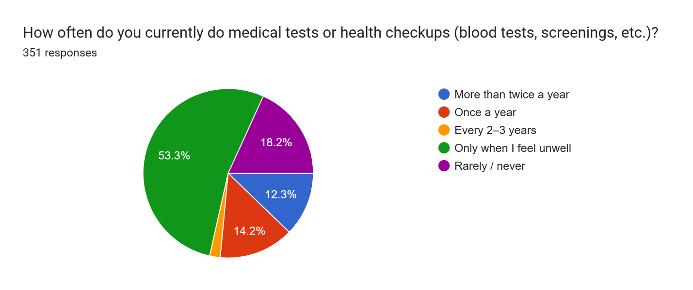
A chart showing how frequently Ghanaians do health checkups.

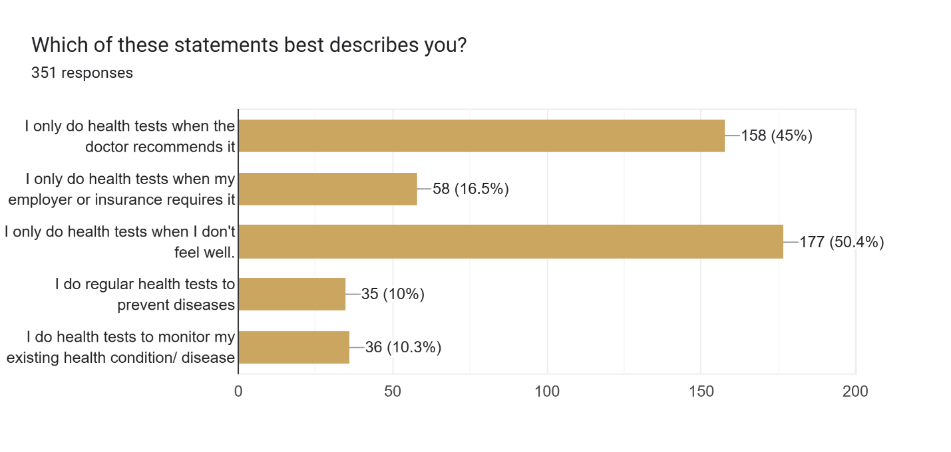
A chart showing Ghanaians' motivation for health checkups

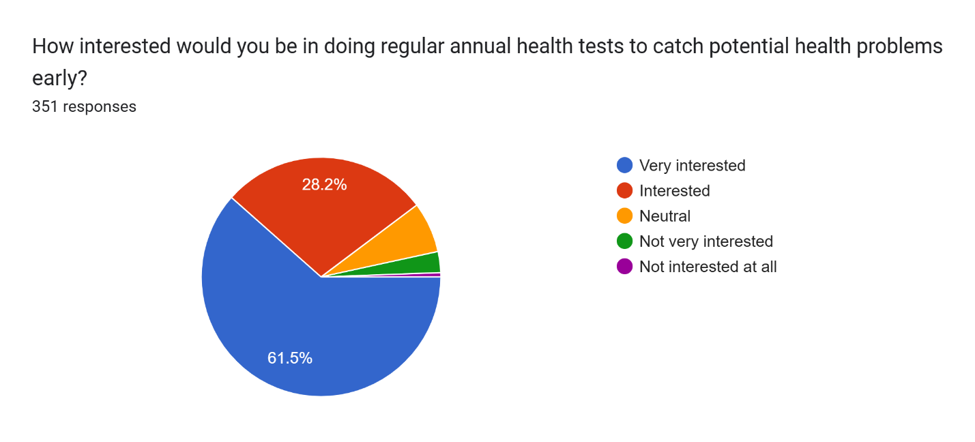
A chart showing Ghanaians’ interest in regular checkups.

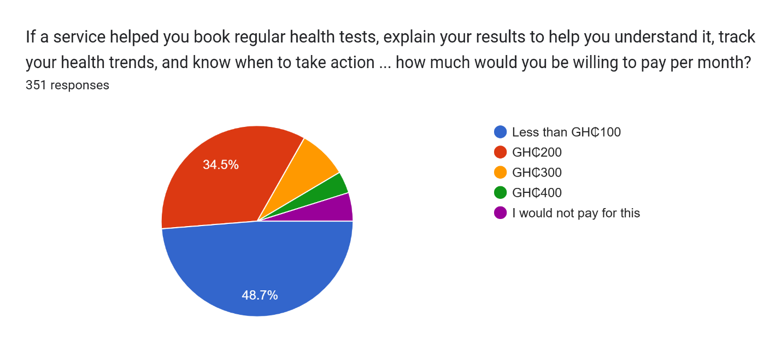
A chart showing the willingness of Ghanaians to pay for preventive healthcare services.

5.0 Discussion

The findings of this study challenge a common assumption that low uptake of preventive healthcare is driven by a lack of awareness or interest. On the contrary, the data shows that 89.7% of individuals are interested in preventive testing, and 95.2% are willing to pay for it. The issue is not demand; it is the absence of systems that enable people to act on that demand.
Ghana's NHIS, established under the National Health Insurance Act of 2003 (Act 650) and revised under Act 852 of 2012, was a landmark achievement in healthcare financing. It covers outpatient and inpatient services, maternity care, emergencies, and a defined list of medications. As of recent estimates, approximately 40–45% of the population has an active NHIS membership.
However, the NHIS was designed primarily as a curative care financing mechanism. Its benefits package does not include routine preventive screening for the general adult population. There is no provision for annual blood work, cancer screening, cardiovascular risk assessment, or metabolic panels for asymptomatic individuals. A Ghanaian who feels well has no NHIS-covered pathway to verify that wellness through clinical
testing.
This structural gap means that the health system effectively waits for people to get sick before engaging with them — precisely the pattern reflected in the survey data.
Ghana's CHPS (Community-based Health Planning and Services) compounds represent the front line of healthcare delivery, particularly in rural areas. There are over 7,000 CHP zones nationwide, staffed by community health nurses and officers. These facilities excel at immunisation, maternal health, and health education but are generally not equipped for laboratory-based preventive screening. They lack the diagnostic infrastructure — blood analysers, specimen handling capacity, and trained laboratory technicians — needed for routine NCD screening. District and regional hospitals have laboratory capacity, but accessing them requires travel, waiting times, and out-of-pocket payments that deter asymptomatic individuals from seeking testing.
Ghana’s healthcare system remains largely reactive. It is structured to respond to illness, manage symptoms, and treat complications. Preventive care, by contrast, is not consistently integrated into routine services. Screening is not widely accessible, and there are limited mechanisms to encourage regular testing.
Consider a conservative scenario, if Ghana could shift just 20% of the currently non-testing population (the 71.5% who test only reactively or never) into annual screening, what might be gained? Approximately 50,000–60,000 additional adults per year could be screened for hypertension, discovering an estimated 15,000–18,000 previously undiagnosed cases (based on 30–35% prevalence and approximately 50% undiagnosed rate).
Early management of these cases through affordable antihypertensive medication could prevent an estimated 2,000–3,000 strokes and heart attacks annually.
Diabetes screening among the same population could identify 3,000–5,000 undiagnosed cases, enabling dietary and pharmaceutical intervention before complications develop.
Cervical cancer screening expansion could detect pre-cancerous lesions in thousands of women, virtually eliminating progression to invasive disease.
The survey data suggests this 20% shift is entirely achievable. With 89.7% expressing interest in regular testing and 95.2% willing to pay, the raw demand far exceeds what even an optimistic policy shift would require.
At the same time, the study highlights a clear opportunity. With 76.3% of respondents comfortable using digital platforms and 88.9% valuing lifetime health tracking, there is strong potential for technology to play a central role in transforming preventive care. Digital platforms could help individuals track their health over time, receive reminders, and better understand their results, thereby bridging the gap between intention and action.

Countries that have invested deliberately in preventive health demonstrate what is possible,
Rwanda, despite a lower GDP per capita than Ghana, has achieved over 90% health
insurance coverage and implemented community-based NCD screening through its extensive community health worker network (Ministry of Health Rwanda, 2020). Rwanda's cervical cancer screening programme, leveraging HPV self-sampling, has reached coverage levels that most African countries have not approached.
In South Korea, the National Health Insurance Corporation provides free biennial health screenings to all insured adults, including cancer screening. South Korea's five-year cancer survival rates are among the highest in the world, driven largely by early detection (NHIC, 2023).
The NHS Health Check programme in the United Kingdom offers free cardiovascular risk assessments to adults aged 40–74 every five years, with modelling suggesting it prevents approximately 2,500 heart attacks and strokes annually (NHS England, 2024).
Ghana does not need to replicate these systems wholesale, but the principle is universal: systematic, population-level preventive screening saves lives and money.

6.0 Conclusion

The data presented in this report tells two stories simultaneously.
The first is a story of neglect of a health system oriented around crisis rather than prevention, of a population that overwhelmingly tests only after symptoms appear, and of preventable diseases quietly progressing in the bodies of people who believe themselves to be well. This neglect carries a heavy price, which includes tens of thousands of premature deaths each year, billions of cedis in avoidable healthcare costs, and immeasurable human suffering in families who lose members to conditions that routine testing could have caught in time.
The second story, however, is one of latent demand and readiness for change. When 89.7% of Ghanaians say they want regular health testing, when 95.2% are willing to pay for it, when 88.9% see lifetime health tracking as valuable, and when 76.3% are ready to engage through digital platforms — this is not a population that needs to be convinced. This is a population that is waiting for the opportunity.
The gap between these two stories is between what is and what could be. It represents both Ghana's greatest public health vulnerability and its greatest public health opportunity. Closing this gap does not require medical breakthroughs or prohibitive investment. It requires political will, policy reform, infrastructure expansion, and the strategic deployment of digital technology to connect a willing population to the preventive services it is asking for.
Every year that passes without action is a year in which thousands of Ghanaians who felt healthy receive devastating diagnoses that earlier testing would have prevented. Every year of inaction is a year in which the intent-action gap — 89.7% wanting, 8.3% doing — persists as a monument to systemic failure. The evidence is clear. The demand is proven. The time to act is now.

7.0 Recommendations

Drawing on the survey findings, Ghana's health system context, and global evidence, this report proposes seven actionable recommendations:
- Establish a National Preventive Screening Programme.
The Government of Ghana, through the Ministry of Health and Ghana Health Service, should establish a structured national screening programme offering at a minimum an annual health assessment for all adults aged 18 and above. The core screening panel should include blood pressure measurement, fasting blood glucose, lipid profile, BMI assessment, and age-appropriate cancer screening (cervical, breast, and prostate). The programme should set coverage targets — e.g., 30% of adults within three years and 60% within seven years — and be integrated into existing CHPS and district health infrastructure.

- Expand NHIS Coverage to Include Preventive Laboratory Tests.
The NHIS benefits package should be revised to include a defined set of annual preventive laboratory tests for all active members. This is perhaps the single most impactful policy change available. When the cost of testing is covered, the survey data strongly suggest uptake will follow: 95.2% of respondents are willing to pay out of pocket, so NHIS coverage would remove whatever residual cost barrier exists. The additional cost to the NHIS can be offset by the long-term savings from reduced emergency and late-stage care.

- Deploy Digital Health Platforms for Results Tracking and Health Literacy.
With 76.3% of respondents comfortable using digital platforms and 88.9% valuing lifetime health tracking, the conditions are ripe for a national digital health records initiative. A mobile-accessible platform that stores longitudinal test results, provides plain-language explanations of lab values, flags abnormal trends, and sends reminders for upcoming tests could address multiple gaps simultaneously: the health literacy deficit (where 35% lack confidence interpreting results), the follow-up failure (where 11.1% ignore "normal" results), and the absence of continuous health monitoring.

- Introduce Employer Wellness Mandates.
Ghana's Labour Act should be amended to require employers above a defined size threshold (e.g., 25+ employees) to provide or facilitate annual health screening for all workers. The survey finding that only 3.4% test due to employer requirements reveals an almost completely untapped channel. Employer-mandated screening is one of the most effective mechanisms for reaching working-age adults who would otherwise not test. This could be implemented through partnerships with accredited laboratories and digital health
platforms, with tax incentives to offset employer costs.

- Scale Community-Based Testing Programmes
Building on the CHPS infrastructure, Ghana should train and equip community health workers to conduct point-of-care testing for key indicators — blood pressure, blood glucose, malaria rapid tests, and BMI — during routine community visits and at designated community health days. This approach brings testing to the population rather than requiring the population to seek out facilities, directly addressing the access barriers that sustain the reactive health culture. Rwanda's community health worker model provides a proven
template.

- Launch Targeted Health Literacy Campaigns
Public health campaigns should be designed to address the specific behavioural patterns revealed by the survey. Counter the "I feel fine" fallacy. Campaigns should educate Ghanaians that the most dangerous diseases, such as hypertension, diabetes, and early-stage cancer, often produce no symptoms until they are advanced. Feeling healthy is not the same as being healthy. Routine testing should be promoted. Shift the cultural narrative from "testing means something is wrong" to "testing means you're taking control."
Improve results literacy. Partner with laboratories and digital platforms to provide clear, accessible explanations of common lab values, what they mean, and when to seek follow-up care.

- Implement Incentive-Based Engagement
Financial and non-financial incentives can bridge the intent-action gap. Possible models include NHIS premium discounts for members who complete annual screening.
Mobile money credits for individuals who complete recommended health checks.
Employers base rewards on additional leave days, insurance premium reductions, or wellness bonuses for employees who participate in screening programmes.
Gamification through digital platforms — health streaks, completion badges, and social sharing features that make preventive health visible and aspirational.
The survey data shows the intent is there: 89.7% want regular testing. Incentives provide the final nudge to convert desire into action.

8.0 References

Primary Data
1. Preventive Health Assessment Survey — Ghana (January 16 – March 25, 2026). Primary survey of 351 Ghanaian respondents on health testing behaviours, attitudes, health literacy, digital readiness,
and willingness to pay for preventive health services.
Secondary Sources
2. World Health Organization. Global Health Observatory — Ghana Country Profile. WHO, 2024.
Available at: https://www.who.int/data/gho
3. World Health Organization. Noncommunicable Diseases Country Profiles: Ghana. WHO, 2024.
4. Ghana Health Service. Annual Report 2023. Accra: Ghana Health Service, 2024.
5. World Bank. World Development Indicators — Ghana. Washington, DC: World Bank Group, 2024.
Available at: https://data.worldbank.org/country/ghana
6. National Health Insurance Authority, Ghana. Annual Report 2023. Accra: NHIA, 2024.
7. International Diabetes Federation. IDF Diabetes Atlas, 10th Edition. Brussels: IDF, 2024.
8. World Health Organization. World Malaria Report 2024. Geneva: WHO, 2024.
9. Agyei-Mensah, S., & de-Graft Aikins, A. "Epidemiological Transition and the Double Burden of
Disease in Accra, Ghana." Journal of Urban Health, 87(5), 2010, pp. 879–897.
10. Bosu, W.K. "Epidemic of Hypertension in Ghana: A Systematic Review." BMC Public Health, 10(418),
2010.
11. Ministry of Health, Ghana. National NCD Policy 2022–2026. Accra: MOH, 2022.
12. Awoonor-Williams, J.K., et al. "The Ghana Essential Health Interventions Programme: A Plausibility
Trial of the Impact of Health Systems Strengthening on Maternal & Child Survival." BMC Health
Services Research, 13(Suppl 2), 2013.
13. Republic of Rwanda, Ministry of Health. Rwanda Non-Communicable Diseases National Strategic
Plan 2020–2025. Kigali: MOH Rwanda, 2020.
14. National Health Insurance Corporation, South Korea. National Health Screening Programme Annual
Report. Seoul: NHIC, 2023.
15. National Health Service, United Kingdom. NHS Health Check Programme Standards. London: NHS
England, 2024.
16. World Health Organization. WHO Package of Essential Noncommunicable (PEN) Disease
Interventions for Primary Health Care. Geneva: WHO, 2020.a

